**Simulating Multivariate Normals in the data step.**

The data set examsub2 is in the s5066/nhanes3 subdirectory.

1. Use a PROC CORR step with this dataset to create a correlation matrix between the variables: bmpht, fvc, fev1, and fev1pc, saving the covariance matrix in a dataset corrsim. Use a PROC PRINT step to examine the dataset corrsim. Restrict the PROC CORR step to those observations having known values for all of the variables

Correct Answer:

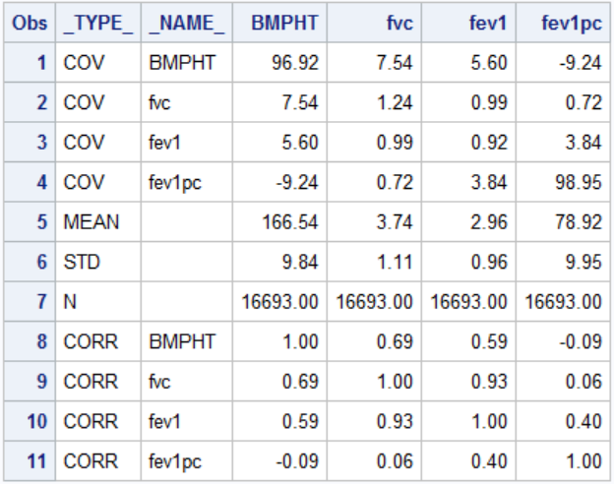

1. Use a PROC SIMNORM step to create a dataset mvndata by generating 1,000 random observations from a multivariate normal distribution having the same covariance structure that was created in the PROC CORR step above. Use 54321 as the seed for the random number generator. The data set mvndata should contain the variables bmpht, fvc, fev1, and fev1pc.
2. Use a PROC CORR step to examine the correlation structure of the variables bmpht, fvc, fev1, and fev1pc on the data set mvndata.

Correct Answer (Partial Output)

